### **ELT Process in Leading US Retail Pharmacy**

#### **Business Context**

A leading US retail pharmacy chain handles vast amounts of transactional, inventory, and customer data daily. This data comes from diverse sources, including APIs (REST and GraphQL), SQL/NoSQL databases, and third-party platforms such as marketing and logistics systems. The company requires a scalable ELT pipeline to ensure high-quality data is transformed and analyzed efficiently.

### **Problem Statement**

The pharmacy faced the following challenges:

1. **Scattered Data Sources:**
   * APIs, SQL/NoSQL databases, and third-party platforms provided data in various formats and frequencies, making it difficult to consolidate.
2. **Data Quality Issues:**
   * Inconsistent customer details, duplicate entries, and missing product information created reporting inaccuracies.
3. **Performance Bottlenecks in Legacy ETL System:**
   * The traditional ETL process extracted and transformed data before loading it into the database.
   * This approach could not handle 2 million new rows daily (~50 million rows in total).
4. **Inefficient Reporting:**
   * Tableau dashboards were slow, taking several minutes to load due to high query complexity.

### **Proposed Solution**

To address these challenges, the company implemented a modern **ELT (Extract-Load-Transform)** architecture with the following components:

1. **Data Sources:** APIs, SQL/NoSQL databases, and third-party platforms.
2. **Data Quality Tool:** **Informatica Data Quality (IDQ)** for profiling, cleansing, and standardization.
3. **Data Destination:** **MySQL** as the centralized data warehouse.
4. **Reporting:** **Tableau** for analytics and visualization.

### **Scenario Details**

#### **Data Sources and Volumes**

1. **APIs (REST, GraphQL):**
   * Customer transactions, loyalty programs, and prescription refills.
   * *Daily Volume:* 1 million rows.
2. **SQL Databases:**
   * Inventory and store-level sales data.
   * *Daily Volume:* 600,000 rows.
3. **NoSQL Databases:**
   * Real-time clickstream data from the pharmacy's e-commerce platform.
   * *Daily Volume:* 300,000 rows.
4. **Third-Party Platforms:**
   * Logistics, marketing campaigns, and supplier data.
   * *Daily Volume:* 100,000 rows.

#### **Solution Architecture**

1. **Extract-Load (EL)**
   * Data is directly extracted from APIs, SQL/NoSQL databases, and third-party platforms in near real-time.
   * Extracted data is loaded **as-is** into staging tables in **MySQL** without transformations.
   * APIs are scheduled to fetch data every 15 minutes, while SQL/NoSQL databases use incremental loads.
2. **Transform (T): ELT in MySQL**
   * Transformations occur inside MySQL using SQL scripts, stored procedures, and views for better performance and scalability.
   * **Key Transformation Steps:**
     + **Data Deduplication:** Identify and remove duplicate customer and transaction records.
     + **Standardization:** Harmonize product names, customer addresses, and date formats.
     + **Aggregations:** Summarize daily transactions, inventory levels, and campaign performance for Tableau.
     + **Data Enrichment:** Join customer loyalty data with transaction history to derive customer lifetime value (CLV).

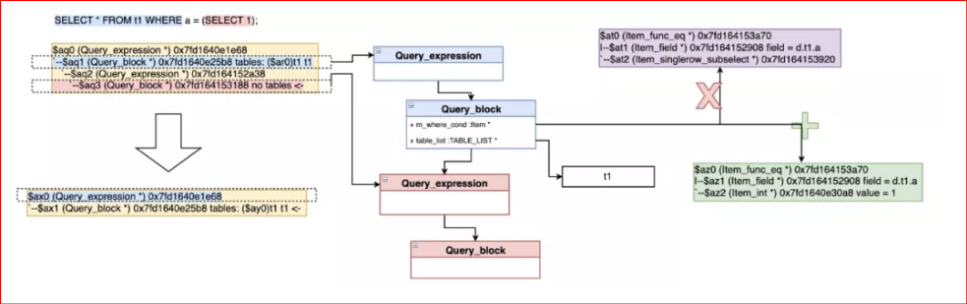

1. **Data Quality with Informatica Data Quality (IDQ):**
   * **Profiling:** Regularly profile data to identify anomalies such as missing or invalid fields.
   * **Cleansing:** Remove duplicates, validate email addresses, and ensure data consistency across sources.
   * **Validation Rules:** Ensure business rules are met, e.g., product price > $0, valid prescription IDs.
2. **Data Destination: MySQL as Centralized Repository**
   * **Partitioning:** Data is partitioned by date to optimize query performance and storage.
   * **Indexing:** Key fields like customer ID, transaction date, and product ID are indexed for faster lookups.
   * **Compression:** Reduces storage costs while maintaining query speed for large tables.
3. **Reporting with Tableau**
   * Tableau connects directly to MySQL’s aggregated and transformed tables.
   * **Dashboards:**
     + **Sales Dashboard:** Displays sales trends by store, region, and product category.
     + **Inventory Dashboard:** Highlights stockouts and overstocked items by location.
     + **Customer Insights Dashboard:** Provides metrics like CLV, loyalty program engagement, and top customers.
   * **Optimizations:** Tableau’s extract mode is used for historical data, while live connections provide real-time updates.

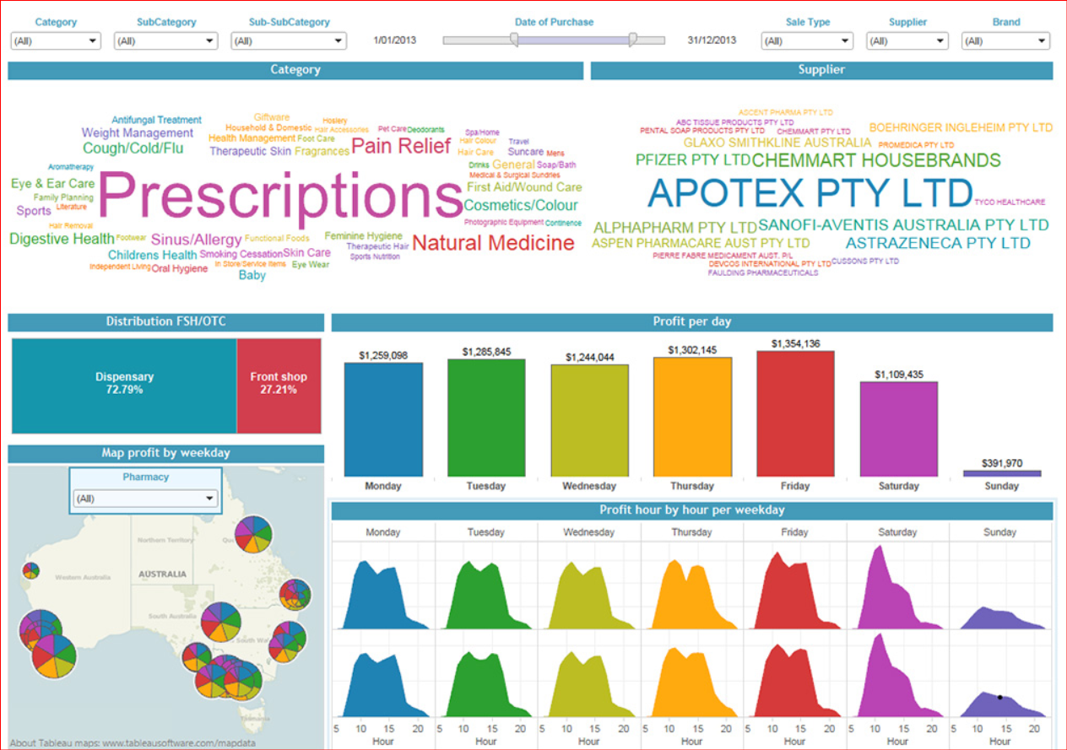

### **Performance Metrics**

1. **Data Volume Management:**
   * 2 million rows daily (~50 million total) are processed efficiently within the MySQL database.
   * ELT ensures that raw data is loaded quickly, with transformations handled during off-peak hours.
2. **Improved Query Performance:**
   * MySQL’s indexing and partitioning reduce query execution times by 40%.
   * Tableau dashboards load in under 5 seconds, down from several minutes previously.
3. **Data Quality:**
   * Informatica Data Quality ensures 99% data accuracy by resolving duplicates and fixing errors during profiling.

### **KPIs Monitored Post-Implementation**

1. **Operational Efficiency:**
   * ETL pipeline execution time reduced from 4 hours to 1.5 hours with ELT.
2. **Reporting Speed:**
   * Tableau dashboard loading time reduced from 3 minutes to under 5 seconds.
3. **Sales Growth Analysis:**
   * Enabled real-time insights into sales trends, increasing revenue by 8% through optimized promotions.
4. **Inventory Optimization:**
   * Reduced stockouts by 15% and overstock by 10% using near-real-time inventory monitoring.
5. **Customer Engagement:**
   * Enhanced loyalty program participation by 20% through data-driven campaign targeting.

### **Benefits of the ELT Approach**

1. **Scalability:**
   * MySQL can handle growing data volumes, ensuring scalability beyond the current 50 million records.
2. **Efficiency:**
   * ELT reduces the need for expensive compute resources during extraction and loading.
3. **Improved Data Quality:**
   * Informatica Data Quality ensures reliable data for decision-making.
4. **Faster Reporting:**
   * Tableau’s optimized dashboards empower executives with actionable insights, improving decision-making speed.

This ELT-based architecture transformed the pharmacy’s data operations, enabling efficient data processing, high-quality reporting, and data-driven decisions.